Rathgael House
43 Balloo Road
Rathgill
Bangor
BT19 7PR

To all Teachers;
DE Staff;
EA Staff;
CCMS Staff; and
ETI Inspectors

27 March 2020

Dear Colleagues

COVID – 19: OUR SCHOOLS NEED YOU

As you are aware and you have heard me say, our society is in the midst of a worldwide crisis and events are changing by the minute.

Our school leaders, teaching and non-teaching staff and boards of governors are playing a critical role in the country’s efforts to combat coronavirus by keeping many schools open to ensure provision is available for vulnerable children and for the children of ‘key workers’ so that services vital for the functioning of society can keep going.

Following the lead of volunteers who have already stepped up to help our vital health services, we in Education want to also play our part. Today, I am asking for your help, in a bid to assist our dedicated teaching staff and non-teaching staff in schools who are carrying out this vital role. We need you to provide essential support and assistance.

At this point in time, it is envisaged that volunteers will work with and support teachers and other education professionals, where they require such support, in carrying out the various duties that supervision of these children entails. You will be fully supported in all tasks which you will be asked to undertake and my Department will seek to place you in schools or centres in your local area, where possible.

The teaching and non-teaching workforce have already been assisting greatly, but we need more people who are willing and able to be of assistance, even if their normal school is not open, to offer their services.

The expectation is that teachers will be deployed in their school (or other schools through local clustering arrangements), or substitute teachers (from the NISTR) will be utilised in the first instance if this is not possible. Public Health Authority guidance in relation to social distancing will be adhered to at all times.

I cannot stress enough how valuable a contribution you would make, not only to our schools, but to society as a whole. Some further guidance will be available on the website.

If you are willing to participate in this very worthwhile and essential work, you should now complete a registration form which will issue by attachment.

Completed applications should be emailed to: Volunteering@education-ni.gov.uk
Please note, to comply with the UK’s current ‘Stay at Home’ rules you may only carry out those tasks which involve leaving your home if you fulfil ALL of the conditions below:
- You are well and have no symptoms like a cough or high temperature and neither does anybody in your household;
- You are under 70;
- You are not pregnant; and
- You do not have any long-term health conditions that make you vulnerable to coronavirus.

Clearance through AccessNI will be required but, in the current circumstances, my Department is working with the Department of Justice to ensure that this can be completed within 24 hours.

Should you volunteer, you will be part of a pool and, depending on a number of factors, it may transpire that you are not ultimately called to participate. If this is the case, I would like to express my sincere gratitude for your willingness to be involved and provide support at this crucial time.

Given the fast moving nature of the current crisis, I would appreciate volunteers for this scheme completing and returning the attached Registration Form by early next week, if possible.

I want to thank you all for your dedication and support in these very difficult times.

Yours sincerely

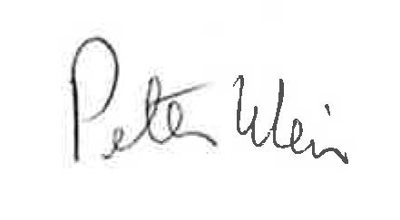
Peter Weir
Minister for Education

