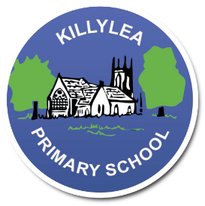
Killylea PS PTA
Autumn Raffle

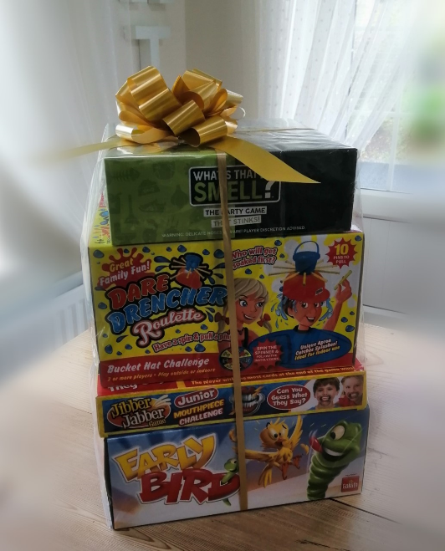
Welcome to our Great Autumn Raffle and thank you for supporting our fundraising efforts by purchasing raffle tickets. Tickets
£1 each or 6 for £5.
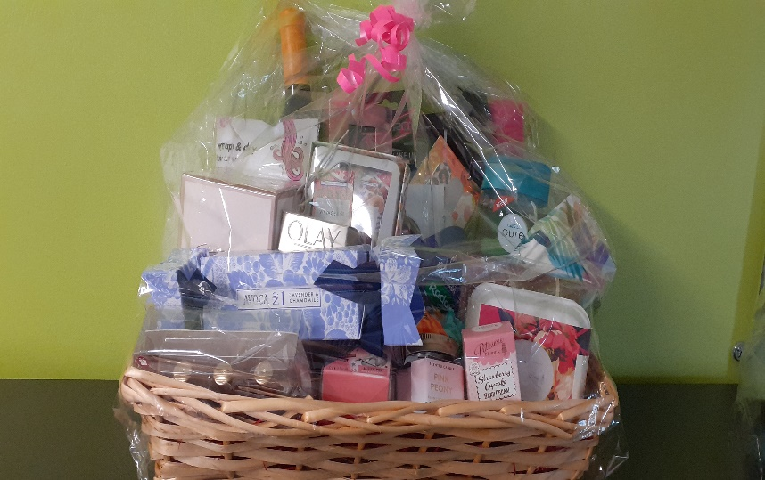
PRIZES TO BE WON INCLUDING:
- Pamper baskets full of goodies
- Large bundle of kids/adult games
- Large teddy bear
- Full set of classic lashes by “Lash Love by Marianne”
- Gel finger and Toe Polish by “Beauty by Me”
- 3 months Membership gym membership by “Maxx Life Gym”
- £25 makeup voucher by “Make Up by Janine”
- £15 voucher for “Nails by Diana Dance”
- Healing arts voucher

There will also be a Pamper Basket prize for the person who has sold the most tickets….so print as many of these sheets as you wish, ask family and friends, and get collecting!!
Please email completed form to guntahutchinson@gmail.com by closing date Friday 20th November 2020 or take a photo of the completed page and send via our PTA whattsapp group if you are a member.
Payment for total amount collected should be made by parents via Parent Pay by Monday 23rd November 2020.
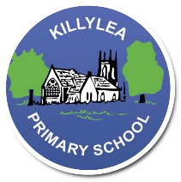
Killylea PS PTA
Autumn Raffle

Name of Seller:

Tickets £1 or 6 for £5.

Name and Contact Phone Number | Name and Contact Phone Number
TOTAL AMOUNT ON THIS SHEET: £

Thank you for supporting Killylea Primary School PTA. Draw will take place on Tues 24th November 2020. 